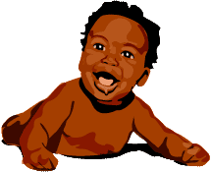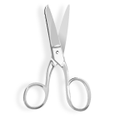

Jackie Robinson played his last season of baseball in **1956**.

Jackie Robinson was born on **January 31, 1919**.

1956

October 24, 1972

Timeline of **Jackie Robinson’s** Life

Jackie Robinson died on **October 24, 1972**.

He played baseball in the Negro League in **1945**.

In **1947** Jackie Robinson became the first African American to play Major League baseball

1947

1945

Glue next page here.

Glue next page here.

Glue next page here.

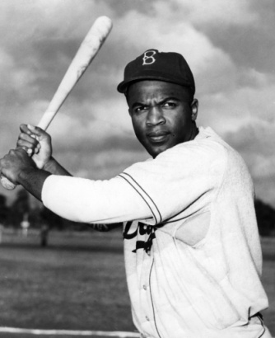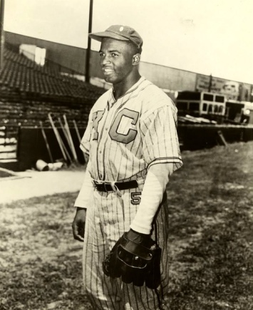C:\Users\William\AppData\Local\Microsoft\Windows\Temporary Internet Files\Content.IE5\YY1DNRXP\MC900216576[1].wmf

January 31, 1919